W-09
YEAR 7 SCIENCE
INVESTIGATING SCIENTIFICALLY
TEST 1: SAFETY AND EQUIPMENT

NAME: FORM: MARK:

1. Name the pieces of laboratory equipment shown below and give the use of each piece.
Name: Name:

Use: Use:

Name: Name:

Use: Use:

(4)

2. A group of students set up the following equipment to measure the change in temperature of the water as it was
heated. In the space to the right of the diagram above, redraw the equipment as it should be represented in an
experimental write-up. Include suitable labels.
(5)

3. Study the diagram below and very clearly indicate (circling with a red pen) FIVE dangers that you see. For
each danger, give a sound REASON why it is a danger.

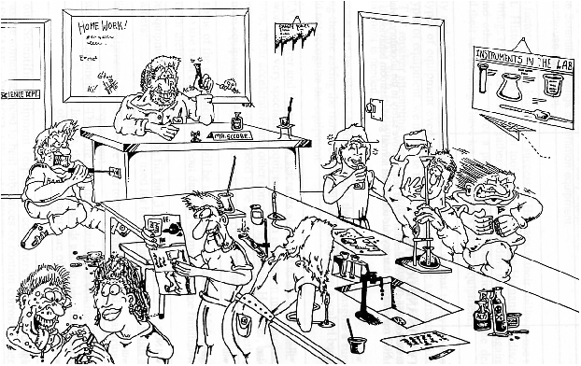

DANGER | REASON

(5)

4. For each of the following situations in the Science laboratory, explain carefully the steps you would take to fix
the problem.

(a) You burn your fingers on a hot tripod.

Step 1

Step 2

(b) A test tube rolls from a table and shatters on the floor. It contained no chemicals.

Step 1

Step 2

(4)

5. (a) Label the diagram of the Bunsen burner below.

(5)

(b) List the steps you would follow in setting up and lighting a Bunsen burner for use in your group.

(i)

(ii)

(iii)

(iv)

(v)

(5)

(c) Complete the following table for the different types of Bunsen flames and their uses.

CHARACTERISTIC | TYPE OF FLAME (COLOUR)
Hottest flame.
Quiet flame.
Safety flame.
Dirty flame when heating glass.
Air hole open.

(5)

